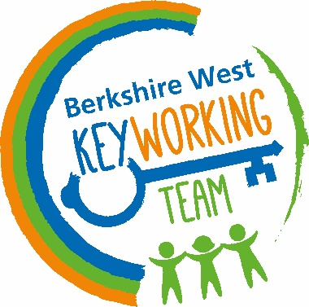

Keyworking Team Berkshire West
Erlegh House
University of Reading
Earley Gate
Whiteknights Road
Reading
RG6 6BZ
Tel: 01189 042 600
keyworkingdsr@berkshire.nhs.uk

Young Person, Adult 18-25, Parent/Carer Consent Form for the
Berkshire West Dynamic Support Register

This consent form is to agree that ……………..……... is to participate with, and receive support, from the Keyworking Team, Berkshire West. This means that information will be held on the Dynamic Support Register (DSR) and will be discussed monthly at the DSR Review Panel. This is a multi-agency meeting chaired by commissioning with Keyworking, Health and Local Authority representation to reduce any barriers in …………………….. needs being met. A Dynamic Support Navigator will be allocated to support navigating Education; Health; Social Care and Voluntary Sector systems to ensure that appropriate support is in place to meet their needs. If an individual is 16 or over, they should sign this consent form (subject to mental capacity assessment if required). *

I have read and understood the information provided to me about the Keyworking Team, Berkshire West and I hereby provide / do not provide (please circle appropriately), written consent for the individual’s name above to participate with the Keyworking Team, Berkshire West and be held on the Dynamic Support Register.

* If a young person 16 or over, is thought not to have the capacity to consent to this decision, an assessment of mental capacity must be carried out and a Best Interests Decision may need to be taken. If this applies, a health or social care worker involved will explain this in more detail. A Best Interests Decision focuses on what is in the best interests of the person and considers the views of those who know the person well.

Consent can be withdrawn at any time by emailing your request to withdraw consent to participate with the Keyworking Team, Berkshire West to: keyworkingdsr@berkshire.nhs.uk

If we receive a request to withdraw consent to participate, your details will be deleted from the DSR records within seven days and you will be closed to the Keyworking Team, Berkshire West on receipt of consent withdrawal. This will not affect the care/treatment you are receiving from any organisation within Health; Education; Social Care or the Voluntary Sector.

Signature: ………………………………………………………………………………………………

Print Name: …………………………………………………………………………………………….

Date: …………………………………………………………………………………………………….

Parent/Carer Details

Name: ………………………………………………………………………………………………….

Contact Number: ………………………………………………………………………………………

Individual’s Details

Name: ………………………………………………………………………………………………….

Date of Birth: …………………………………………………………………………………………...

An Easy Read version of the information leaflet is attached.

