**Incontinence Associated Dermatitis Pathway**

STEP DOWN

**SEVERE IAD**

Wash skin with Medi Derma-Pro Foam and Spray Incontinence Cleanser and apply Medi Derma-Pro Skin Protectant Ointment after each episode of incontinence.

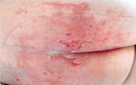

**MODERATE IAD**

Wash skin with suitable skin cleansing agent and pat dry after each episode of incontinence. Apply Medihoney barrier cream, if mild fungal infection or less than 50% skin damage (leave 5 minutes to dry before applying barrier cream). Medi Derma S Barrier Film can be applied if there is no clinical evidence of infection.

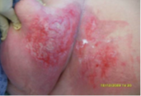

**MILD IAD**

Wash skin thoroughly with suitable skin cleansing agent and pat dry after each episode of incontinence. Apply a pea-sized amount of Derma-S Total Barrier Cream after every third wash.

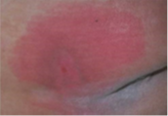

**PREVENTATIVE**

Wash skin with suitable skin cleansing agent and pat dry after each episode of incontinence. Apply emollient to optimise skin health.

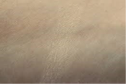

**Step Up**

**Step Down**